Dropbox
(Cloud File Storage)
- What is this system and why is this used?
  - Cloud file storage enables users to store their data on remote servers. Usually, these servers are maintained by cloud storage providers and made available to users over a network (typically through the Internet). Users pay for their cloud data storage on a monthly basis.
  - Cloud file storage services have become very popular recently as they simplify the storage and exchange of digital resources among multiple devices. The shift from using single personal computers to using multiple devices with different platforms and operating systems such as smartphones and tablets each with portable access from various geographical locations at any time, is believed to be accountable for the huge popularity of cloud storage services.
  - Following are some of the top benefits of such services:
    - Availability: The motto of cloud storage services is to have data availability anywhere, anytime. Users can access their files/photos from any device whenever and wherever they like.
    - Reliability and Durability: Another benefit of cloud storage is that it offers 100% reliability and durability of data. Cloud storage ensures that users will never lose their data by keeping multiple copies of the data stored on different geographically located servers.
    - Scalability: Users will never have to worry about getting out of storage space. With cloud storage you have unlimited storage as long as you are ready to pay for it.
  - abc
- Goals and Requirements of the system:
  - functional requirements
    - Users should be able to upload and download their files/photos from any device.
    - Users should be able to share files or folders with other users.
    - Our service should support automatic synchronization between devices, i.e., after updating a file on one device, it should get synchronized on all devices.
    - The system should support storing large files up to a GB.
    - Our system should support offline editing. Users should be able to add/delete/modify files while offline, and as soon as they come online, all their changes should be synced to the remote servers and other online devices.
  - non-functional requirements
    - ACID-ity is required. Atomicity, Consistency, Isolation and Durability of all file operations should be guaranteed.
  - extended requirements
    - The system should support snapshotting of the data, so that users can go back to any version of the files.
- Workflow:
The user will specify a folder as the workspace on their device. Any file/photo/folder placed in this folder will be uploaded to the cloud, and whenever a file is modified or deleted, it will be reflected in the same way in the cloud storage. The user can specify similar workspaces on all their devices and any modification done on one device will be propagated to all other devices to have the same view of the workspace everywhere.
- Nature of business:
- Type of users:
- Some Design Considerations,
  - We should expect huge read and write volumes.
  - Read to write ratio is expected to be nearly the same.
  - Internally, files can be stored in small parts or chunks (say 4MB); this can provide a lot of benefits i.e. all failed operations shall only be retried for smaller parts of a file. If a user fails to upload a file, then only the failing chunk will be retried.
  - We can reduce the amount of data exchange by transferring updated chunks only.
  - By removing duplicate chunks, we can save storage space and bandwidth usage.
  - Keeping a local copy of the metadata (file name, size, etc.) with the client can save us a lot of round trips to the server.
  - For small changes, clients can intelligently upload the diffs instead of the whole chunk.
- UI:
- System APIs,
  - API for file chunk upload:
chunkUpload(fileName, chunkName, chunkData)
  - API for metadata update from client to the server:
metadataUpload(fileName, chunks[], epoch)
  - API for metadata update from server to the client:
metadataDownload()
  - API for file chunk download:
chunkDownload(chunkName)
- Capacity Estimation and Constraints: Estimation will help us understand our system better.
We will apply 30 : 50 : 70 capacity model for bandwidth, memory and storage.
  - Estimate of number of users and their uses,
    - Let’s assume that we have 500M total users, and 100M daily active users (DAU). Let’s also assume that 10 million users are active at any time.
    - Let’s assume that on average each user connects from three different devices.
    - On average if a user has 200 files/photos, we will have 100 billion total files.
    - Suppose, on average each user changes 5 files per day.
  - Estimate of read and write ratio,
As we have estimated that on average each user connects from three different devices, so write from any one device will be replicated on the other two devices. So our write and read ratio will be 1 : 2.
  - Storage estimates,
Let’s assume that average file size is 100KB, this would give us ten petabytes of total storage.
100B * 100KB => 10PB
  - Traffic estimates,
    - Per day hit of API for file chunk upload:
As there are 100 M daily active users and they change on average five files per day, so number of chunk upload hits per day = 100 M * 5 = 500 M.
    - Per day hit of API for file chunk download:
Number of chunk download hits = 500 M * 2 = 1 Billion
(as each uploaded chunk will be downloaded on two other client devices)
    - Per day hit of API for metadata upload:
As the file chunks are of size 4 MB and the average file size is 100 KB so the number of metadata upload hits will also be almost equal to the number of files as most of the files will have only one chunk. So number of metadata upload hits per day = 100 M * 5 = 500 M
    - Per day hit of API for metadata download:
Number of metadata download hits per day = 1 Billion
  - Bandwidth estimates,
    - Per day data being uploaded to the block storage = 100 M * 5 * 100 KB = 50 TB
    - And each uploaded data will be downloaded to 2 other client devices. So average data download per day = 100 TB
Data transfer for metadata update will be negligible in comparison of file data transfer. So total bandwidth required will be 150 TB per day or around 1.8 GB per second.
  - Memory estimates,
- Database design,
Covered in Detailed Component Design.
- Algorithm,
- Technology stack,
  - backend: Java, Springboot,
- Basic system design,
At a high level, we need to store files and their metadata information like File Name, File Size, Directory, etc., and who this file is shared with. So, we need some servers that can help the clients to upload/download files to Cloud Storage and some servers that can facilitate updating metadata about files and users. We also need some mechanism to notify all clients whenever an update happens so they can synchronize their files.

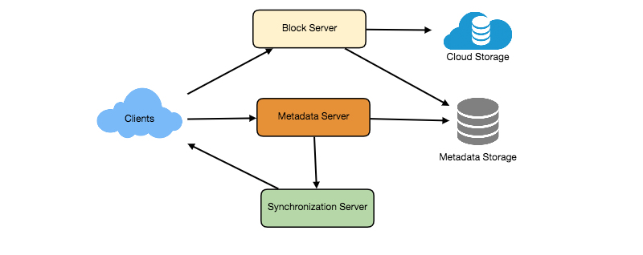
As shown in the diagram above, Block servers will work with the clients to upload/download files from cloud storage and Metadata servers will keep metadata of files updated in a SQL or NoSQL database. Synchronization servers will handle the workflow of notifying all clients about different changes for synchronization.

- Detailed Component design,
For detailed component design, see the following documents:
Dropbox.jpeg

From these documents, it is evident that we have following major components in our system:
client, metadata database, synchronization service, message queuing service, cloud/block storage. We are going to discuss all these major components one by one.
  - Client,
The Client Application monitors the workspace folder on the user’s machine and syncs all files/folders in it with the remote Cloud Storage. The client application will work with the storage servers to upload, download, and modify actual files to backend Cloud Storage. The client also interacts with the remote Synchronization Service to handle any file metadata updates, e.g., change in the file name, size, modification date, etc.

Here are some of the essential operations for the client:
A) Upload and download files.
B) Detect file changes in the workspace folder.
C) Handle conflict due to offline or concurrent updates.

How do we handle file transfer efficiently? As mentioned above, we can break each file into smaller chunks so that we transfer only those chunks that are modified and not the whole file. Let’s say we divide each file into fixed sizes of 4MB chunks. We can statically calculate what could be an optimal chunk size based on 1) Storage devices we use in the cloud to optimize space utilization and input/output operations per second (IOPS) 2) Network bandwidth 3) Average file size in the storage etc. In our metadata, we should also keep a record of each file and the chunks that constitute it.

Should we keep a copy of metadata with Client? Keeping a local copy of metadata not only enable us to do offline updates but also saves a lot of round trips to update remote metadata.

How can clients efficiently listen to changes happening with other clients? One solution could be that the clients periodically check with the server if there are any changes. The problem with this approach is that we will have a delay in reflecting changes locally as clients will be checking for changes periodically compared to a server notifying whenever there is some change. If the client frequently checks the server for changes, it will not only be wasting bandwidth, as the server has to return an empty response most of the time, but will also be keeping the server busy. Pulling information in this manner is not scalable.
A solution to the above problem could be to use HTTP long polling. With long polling the client requests information from the server with the expectation that the server may not respond immediately. If the server has no new data for the client when the poll is received, instead of sending an empty response, the server holds the request open and waits for response information to become available. Once it does have new information, the server immediately sends an HTTP/S response to the client, completing the open HTTP/S Request. Upon receipt of the server response, the client can immediately issue another server request for future updates.

Based on the above considerations, we can divide our client into following four parts:
I. Internal Metadata Database will keep track of all the files, chunks, their versions, and their location in the file system.
II. Chunker will split the files into smaller pieces called chunks. It will also be responsible for reconstructing a file from its chunks. Our chunking algorithm will detect the parts of the files that have been modified by the user and only transfer those parts to the Cloud Storage; this will save us bandwidth and synchronization time.
III. Watcher will monitor the local workspace folders and notify the Indexer (discussed below) of any action performed by the users, e.g. when users create, delete, or update files or folders. Watcher also listens to any changes happening on other clients that are broadcasted by Synchronization service.
IV. Indexer will process the events received from the Watcher and update the internal metadata database with information about the chunks of the modified files. Once the chunks are successfully submitted/downloaded to the Cloud Storage, the Indexer will communicate with the remote Synchronization Service to broadcast changes to other clients and update remote metadata database.
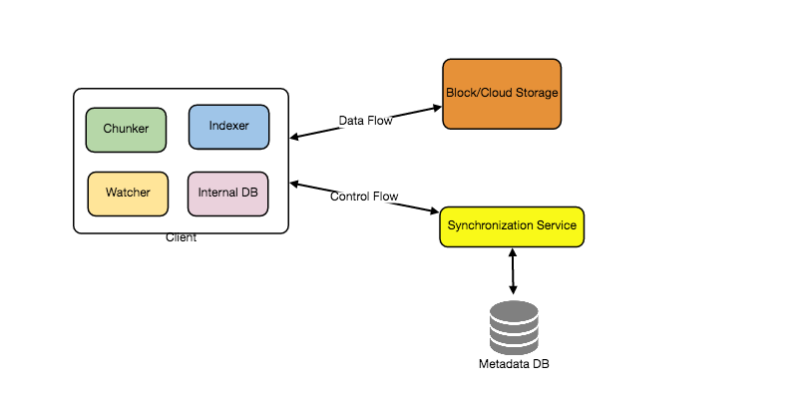

How should clients handle slow servers? Clients should exponentially back-off if the server is busy/not-responding. Meaning, if a server is too slow to respond, clients should delay their retries and this delay should increase exponentially.

Should mobile clients sync remote changes immediately? Unlike desktop or web clients, mobile clients usually sync on demand to save user’s bandwidth and space.
  - Metadata database,
The Metadata Database is responsible for maintaining the versioning and metadata information about files/chunks, users, devices and workspaces. The Metadata Database can be a relational database such as MySQL, or a NoSQL database service such as DynamoDB. Regardless of the type of the database, the Synchronization Service should be able to provide a consistent view of the files using a database, especially if more than one user is working with the same file simultaneously. Since NoSQL data stores do not support ACID properties in favor of scalability and performance, we need to incorporate the support for ACID properties programmatically in the logic of our Synchronization Service in case we opt for this kind of database. However, using a relational database can simplify the implementation of the Synchronization Service as they natively support ACID properties.
The metadata Database should be storing information about following objects:
    - Chunks
    - Files
    - User
    - Devices
    - Workspace (sync folders)
  - Synchronization Service,
The Synchronization Service is the component that processes file updates made by a client and applies these changes to other subscribed clients. It also synchronizes clients’ local databases with the information stored in the remote Metadata DB. The Synchronization Service is the most important part of the system architecture due to its critical role in managing the metadata and synchronizing users’ files. Clients communicate with the Synchronization Service to either obtain updates from the Cloud Storage or send files and updates to the Cloud Storage and, potentially, other users. If a client was offline for a period, it polls the system for new updates as soon as they come online. When the Synchronization Service receives an update request, it checks with the Metadata Database for consistency and then proceeds with the update. Subsequently, a notification is sent to all subscribed users or devices to report the file update.
The Synchronization Service should be designed in such a way that it transmits less data between clients and the Cloud storage to achieve a better response time. To meet this design goal, the Synchronization Service can employ a differencing algorithm to reduce the amount of data that needs to be synchronized. Instead of transmitting entire files from clients to the server or vice versa, we can just transmit the difference between two versions of a file. Therefore, only the part of the file that has been changed is transmitted. This also decreases bandwidth consumption and cloud data storage for the end user. As described above, we will be dividing our files into 4MB chunks and will be transferring modified chunks only. Server and clients can calculate a hash (e.g., SHA-256) to see whether to update the local copy of a chunk or not. On the server, if we already have a chunk with a similar hash (even from another user), we don’t need to create another copy, we can use the same chunk. This is discussed in detail later under Data Deduplication.
To be able to provide an efficient and scalable synchronization protocol we can consider using a communication middleware between clients and the Synchronization Service. The messaging middleware should provide scalable message queuing and change notifications to support a high number of clients using pull or push strategies. This message queue solution is apt here as it is not a UI application where http get request needs the response immediately. Here the metadata change happened at any client can be sent into the queue and just an ack will be enough for the client. Now its the responsibility of the server to process this data. This way, multiple Synchronization Service instances can receive requests from a global request Queue, and the communication middleware will be able to balance its load.
  - Message Queuing Service,
An important part of our architecture is a messaging middleware that should be able to handle a substantial number of requests. A scalable Message Queuing Service that supports asynchronous message-based communication between clients and the Synchronization Service best fits the requirements of our application. The Message Queuing Service supports asynchronous and loosely coupled message-based communication between distributed components of the system. The Message Queuing Service should be able to efficiently store any number of messages in a highly available, reliable and scalable queue.
The Message Queuing Service will implement two types of queues in our system. The Request Queue is a global queue and all clients will share it. Clients’ requests to update the Metadata Database will be sent to the Request Queue first, from there the Synchronization Service will take it to update metadata. The Response Queues are responsible for delivering the update messages to each client. The Response Queues can be implemented in two ways:
    - We will need to create separate Response Queues for each subscribed client to share update messages if we want to implement pull mechanism by clients for the changes happening on the other client. For pull mechanism, either we will need separate queues for all the subscribed clients or we can have some DB table where we can store all these changes for all the clients and during the pull call by any client, we can filter his data from the table.
    - If we are implementing push mechanism by the server to the clients for the changes happening on the other clients, one global response queue or shared response queue (for some 100 or 1000 subscribed clients) can also work (as explained for Messanger service).

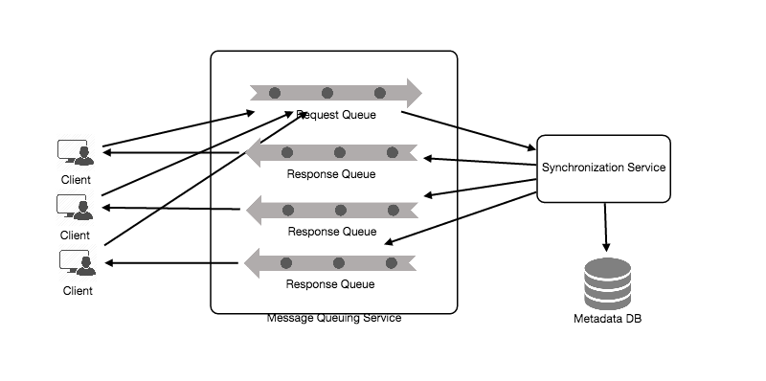
  - Cloud/Block Storage,
Cloud/Block Storage stores chunks of files uploaded by the users. Clients directly interact with the storage to send and receive objects from it. Separation of the metadata from storage enables us to use any storage either in the cloud or in-house.

How will this system be working (file processing workflow)?
The sequence below shows the interaction between the components of the application in a scenario when Client A updates a file that is shared with Client B and C, so they should receive the update too. If the other clients are not online at the time of the update, the Message Queuing Service keeps the update notifications in separate response queues for them until they come online later.
A) Client A changes a file (file name: xyz) of size 20 MB. Suppose the name (uuid) of its chunks are abc-1, abc-2, abc-3, abc-4, abc-5.
B) Suppose this file change includes the change of two chunks of the file and the changed file chunks are abc-1 and abc-3 and all the chunks of the file now are abc-11, abc-2, abc-31, abc-4, abc-5.
C) Now first the client tries to upload the file chunks abc-11 and abc31. On their successful upload on the block storage, Client A updates metadata and commits changes.
D) Client A gets confirmation and notifications are sent to Clients B and C about the changes.
E) Client B and C receive metadata changes and download updated chunks.
F) Now file chunks abc-1 and abc-3 is not being refered by the file xyz. If these file chunks don’t have any reference in any other file, these file chunks can be removed during purging or DB cleanup.
- Concurrency,
- Data Partitioning,
To scale out metadata DB, we need to partition it so that it can store information about millions of users and billions of files/chunks. We need to come up with a partitioning scheme that would divide and store our data in different DB servers.
  - Vertical Partitioning: We can partition our database in such a way that we store tables related to one particular feature on one server. For example, we can store all the user related tables in one database and all files/chunks related tables in another database. Although this approach is straightforward to implement it has some issues:
    - Will we still have scale issues? What if we have trillions of chunks to be stored and our database cannot support storing such a huge number of records? How would we further partition such tables?
    - Joining two tables in two separate databases can cause performance and consistency issues. How frequently do we have to join user and file tables?
  - Range Based Partitioning: What if we store files/chunks in separate partitions based on the first letter of the File Path? In that case, we save all the files starting with the letter ‘A’ in one partition and those that start with the letter ‘B’ into another partition and so on. This approach is called range based partitioning. We can even combine certain less frequently occurring letters into one database partition. We should come up with this partitioning scheme statically so that we can always store/find a file in a predictable manner.
The main problem with this approach is that it can lead to unbalanced servers. For example, if we decide to put all files starting with the letter ‘E’ into a DB partition, and later we realize that we have too many files that start with the letter ‘E’, to such an extent that we cannot fit them into one DB partition.
  - Hash-Based Partitioning: In this scheme we take a hash of the object we are storing and based on this hash we figure out the DB partition to which this object should go. In our case, we can take the hash of the ‘FileID’ of the File object we are storing to determine the partition the file will be stored. Our hashing function will randomly distribute objects into different partitions, e.g., our hashing function can always map any ID to a number between [1…256], and this number would be the partition we will store our object.
- Service Component Partitioning,
- Data replication,
To ensure the high availability, we need to have at least three replicas of every partition of the database. Among these three replicas, one will be the master (which will be used for all the writes and may also be used for reads) and the other two will be the slaves (both of which may be used for reads or we may keep one of them on hot-standby).
- Data archiving,
In this case we archive the older data by transferring it on some less expensive, low configuration database set up. When we get some read query, we will search our data in following way:
  - First search the data in cache and if it is found in cache, serve it,
  - If the data is not found in cache go to main database, get the data and update the data in the cache,
  - If the data is not found in main database as well, go to archive database, get the data and update the data in the cache,
  - If the data is not found even in arviches, return the not found status in the response.
This data archiving will involve:
A) writing of older data (say data older between one to two week) from our main database to the archive database,
B) verification of the written data that whether it is properly written or not and
C) if it is properly written on archive database cluster, then deletion of that older data (one week older to two week older) from our main database.
We run this archiving process on some schedule (say daily, weekly or monthly but neither too quickly nor not at all).
- Cache,
We can have two kinds of caches in our system. To deal with hot files/chunks we can introduce a cache for Block storage. We can use an off-the-shelf solution like Memcached that can store whole chunks with its respective IDs/Hashes and Block servers before hitting Block storage can quickly check if the cache has desired chunk. Based on clients’ usage pattern we can determine how many cache servers we need. A high-end commercial server can have 144GB of memory; one such server can cache 36K chunks. Apart from this block storage cache, we should also have metadata cache.
Which cache replacement policy would best fit our needs? When the cache is full, and we want to replace a chunk with a newer/hotter chunk, how would we choose? Least Recently Used (LRU) can be a reasonable policy for our system. Under this policy, we discard the least recently used chunk first. Load Similarly, we can have a cache for Metadata DB.
- Fault Tolerance
The service is partitioned at all the components, there are multiple web servers, multiple application servers and other servers as well. Our database is also partitioned on the basis of hash and every partition have master – slave configuration. So our service is fault tolerent at all the components.
- Where to add load balancers?
We can add the Load balancing layer at two places in our system: 1) Between Clients and Block servers and 2) Between Clients and Metadata servers. Initially, a simple Round Robin approach can be adopted that distributes incoming requests equally among backend servers. This LB is simple to implement and does not introduce any overhead. Another benefit of this approach is if a server is dead, LB will take it out of the rotation and will stop sending any traffic to it. A problem with Round Robin LB is, it won’t take server load into consideration. If a server is overloaded or slow, the LB will not stop sending new requests to that server. To handle this, a more intelligent LB solution can be placed that periodically queries backend server about their load and adjusts traffic based on that.
- Purging or DB cleanup,
This job can be run daily or weekly when the load on the server is less. We should maintain the information in the metadata DB for all the file chunks that it is being referred by how many files. For example: {chunk_1, [file_3, file_11]}, {chunk_2, [file_3, file_17]}. During purging, we can scan this table and if there is any file chunk which is not being used by any of the file, then we can remove it from the block storage.
- Data deduplication,
Data deduplication is a technique used for eliminating duplicate copies of data to improve storage utilization. It can also be applied to network data transfers to reduce the number of bytes that must be sent. For each new incoming chunk, we can calculate a hash of it and compare that hash with all the hashes of the existing chunks to see if we already have the same chunk present in our storage.
We can implement deduplication in two ways in our system:
  - Post-process deduplication: With post-process deduplication, new chunks are first stored on the storage device and later some process analyzes the data looking for duplication. The benefit is that clients will not need to wait for the hash calculation or lookup to complete before storing the data, thereby ensuring that there is no degradation in storage performance. Drawbacks of this approach are 1) We will unnecessarily be storing duplicate data, though for a short time, 2) Duplicate data will be transferred consuming bandwidth.
  - In-line deduplication: Alternatively, deduplication hash calculations can be done in real-time as the clients are entering data on their device. If our system identifies a chunk that it has already stored, only a reference to the existing chunk will be added in the metadata, rather than a full copy of the chunk. This approach will give us optimal network and storage usage.
- Security,
One of the primary concerns users will have while storing their files in the cloud is the privacy and security of their data, especially since in our system users can share their files with other users or even make them public to share it with everyone. To handle this, we will be storing the permissions of each file in our metadata DB to reflect what files are visible or modifiable by any user.
- Optimizations on the client to improve user experience,
  - client cache,
(Cache at the end of client is crucial for assets that are rarely changing),
  - try to reduce the number of http requests,
  - avoid 301 redirects,
(Redirects are performance killers. Avoid them whenever possible.),
- User Persionalization,
- Advanced Issues,
- Deployment,
  - docker,
  - kubernete,
  - autoscaling,
  - all internal servers will be deployed on vpn,
- Analytics,
  - Some statistics worth tracking: country of the visitor, date and time of access, frequency of file changes, size of files, type of file, etc. These analytics data will be used to understand the trends of use of the service.
  - Realtime analytics is not required. So we could simply MapReduce the Web Server logs to generate hit counts.
  - We should store both types of logs, i.e write logs as well as read logs.
  - By analyzing the read and write logs, we can also know about number of hits from areas and we can take decision to increase or decrease number of servers or CDNs for that area.
- Monitoring: Having the ability to monitor our systems is crucial. We should constantly collect data to get an instant insight into how our system is doing. We can collect following metrics/counters to get an understanding of the performance of our service:
  - No. of hits per day,
  - No. of hits per second and what is the daily peak?
  - Amount of data coming in and going out per day,
  - Amount of data coming in and going out per second and what is the daily peak?
  - Average latency seen by the user,

By monitoring these counters, we will realize if we need more replication or load balancing or caching, etc.
Continue benchmarking and monitoring your system to address bottlenecks as they come up. Scaling is an iterative process.
- Follow up questions:
abc

